

**Business Requirements Document (BRD)**

**Product Name**: REVOZI.AI  
**Purpose**: To create a platform leveraging Voice AI, enabling businesses to qualify leads, schedule appointments, and efficiently manage inbound and outbound communications.

**Main Attributes**:

1. **Voice AI**: Powered by BLAND.AI for call handling, transcription, and summarization.
2. **System/Platform**: Built using ASP.NET (backend) and Angular (frontend).
3. **Third-party Integrations**: Includes Meta, Google, HubSpot, Zapier, Twilio, Stripe, and scheduling platforms like Gmail, Outlook, and Calendly.

**Functional Requirements**

**1. Lead Management**:

* **Lead Import**:
  + Integrate with Meta, Google, HubSpot, Zapier, and LinkedIn Ads for automatic lead import.
  + Allow manual import via Excel/CSV files.
  + On upload, display a mapping popup for column assignment (e.g., Name, Email, Phone Number).
  + Use N8N or direct integration for data flow from third-party systems.
  + **Key Fields**:
    - Name, Email, Phone Number.
    - Optional Fields: Company, Notes, Source.
* **Lead Call Scheduling**:
  + Enable configurable call scheduling based on client settings (e.g., 30 seconds, 2 minutes, 5 minutes).
  + Frontend triggers .NET backend API, which communicates with BLAND.AI to make calls based on tenant-specific configurations.
  + **Key Fields**:
    - Lead ID, Preferred Call Time, Status, Configuration Settings.
* **Lead Download**:
  + Allow users to download leads directly from the system.
  + This feature will be controlled by permission management.
  + **Key Fields**:
    - Lead Source, Status, Date Range, and Filters applied.

**2. Telephony Integration**:

* Integrate Twilio for:
  + Tenant-specific phone number purchases.
  + API support for managing numbers and associated keys.
  + **Key Fields**:
    - Tenant ID, Purchased Number, API Key.
* Use Twilio APIs for call handling and recordings.

**3. Call Management**:

* **Call Handling**:
  + BLAND.AI backend processes calls, provides transcripts, and generates summary tags.
* **Recording and Logs**:
  + Fetch call recordings via Twilio API.
  + Display detailed call logs with duration, cost ($0.25/min), and associated transaction details.
  + **Key Fields**:
    - Call ID, Lead ID, Duration, Cost, Recording URL, Transcript Summary.

**4. Payment Gateway**:

* Integrate Stripe for payment processing.
* Offer the following incentives:
  + First 5 calls free.
  + $20 coupon for webinar attendees.
  + **Key Fields**:
    - Payment ID, Tenant ID, Amount, Coupon Code, Usage Count.

**5. Dashboard**:

* Summarize metrics such as total leads, qualified leads, and connected leads.
* Include widgets showcasing status groupings based on transcript summary tags.
  + **Key Fields**:
    - Total Leads, Qualified Leads, Connected Leads, Transcript Status Tags.

**6. Scheduling and Events**:

* Sync with scheduling platforms (e.g., Gmail, Outlook, Calendly) based on tenant preferences.
* Provide a centralized calendar view for meetings and appointments.
  + **Key Fields**:
    - Event ID, Tenant ID, Scheduled Time, Status, Integration Platform.

**7. Chatbot Functionality**:

* Develop a chatbot interface similar to ChatGPT.
* Enable tenants to query data, including calls, summaries, and event keywords extracted from transcripts.
  + **Key Fields**:
    - Query, Response, Context (e.g., Call Data, Summary, Keywords).

**8. Signup Screen**:

* **Option 1: Manual Signup**:
  + Fields:
    - Name (Text input)
    - Email Address (Email input)
    - Password (Password input)
    - Job Title (Dropdown with options like: Freelancer, C-level Executive, Manager, Operations, Founder, Individual Contributor, Other)
    - Use Case (Dropdown with options like: Sales, Recruiting, High Volume Customer Support, Email Automation, Scheduling, Workflow Automation, Other)
    - Source (Dropdown: Where did you hear from us?)
* **Option 2: Google Signup**:
  + Post-Google authentication, collect additional fields:
    - Job Title
    - Use Case

**Screen Requirements**

**1. Lead Import Screen**:

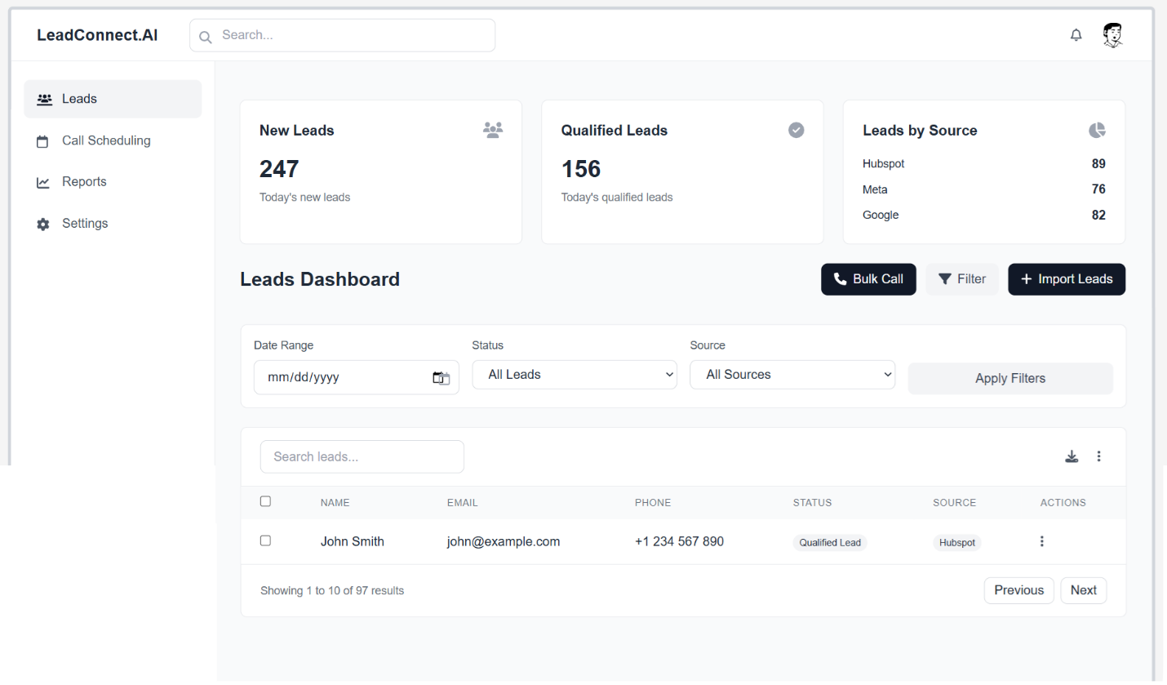

* UI for lead import via third-party integrations or manual upload.
* Popup for column mapping upon file upload.
  + **Key Elements**:
    - File Upload, Column Mapping Popup, Validation Errors.
* **Filters**:
  + Source: Display options for lead origin (e.g., Meta, Google, Zapier, Manual Import).
  + Status: Allow filtering based on lead status (e.g., New, Qualified, Unqualified).
  + Date Range: Enable filtering leads within a specific date range.
* **Agile View Mode**: (Phase 2)
  + Display leads grouped by status (e.g., New, In Progress, Completed) in a drag-and-drop Kanban-style interface.

**2. Lead Detail Screen**:

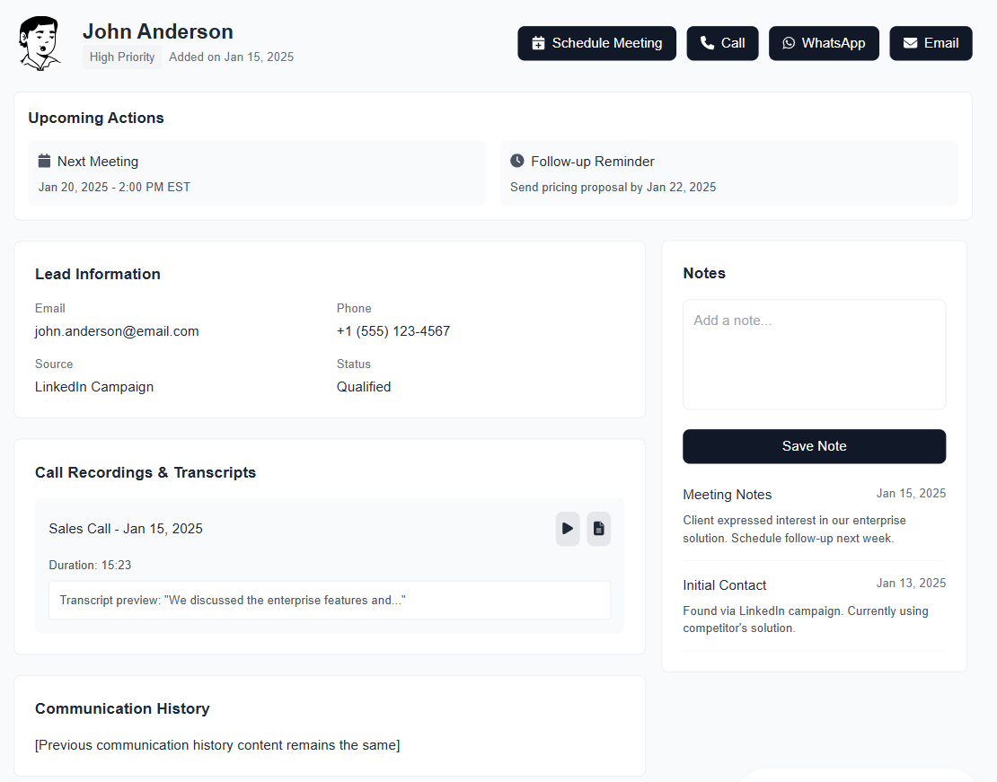

* Display detailed information about a lead.
  + **Lead Information**:
    - Name, Email, Phone Number, Source, Status, Notes.
  + **Call History**:
    - List of all calls made to the lead, including timestamps, call duration, and outcomes.
    - Provide options to play call recordings directly from the interface.
    - Display the transcript of each call for easy review.
  + **Communication Log**:
    - Record of WhatsApp messages sent to the lead.
    - Record of emails sent to the lead, including subject and timestamps.
    - Automatically send an email confirmation to the potential customer after a meeting is scheduled through the system.
  + **Scheduled Actions**:
    - Display any scheduled meetings or follow-ups associated with the lead.
    - Allow the system to trigger reminders or actions based on the schedule.
  + **Actions**:
    - Provide an interface to send WhatsApp messages with a dedicated panel.
    - Show a popup interface for composing and sending emails.
    - Include options for initiating calls, either automatically using AI or manually, with clear controls.

**3. Call Configuration Screen**:

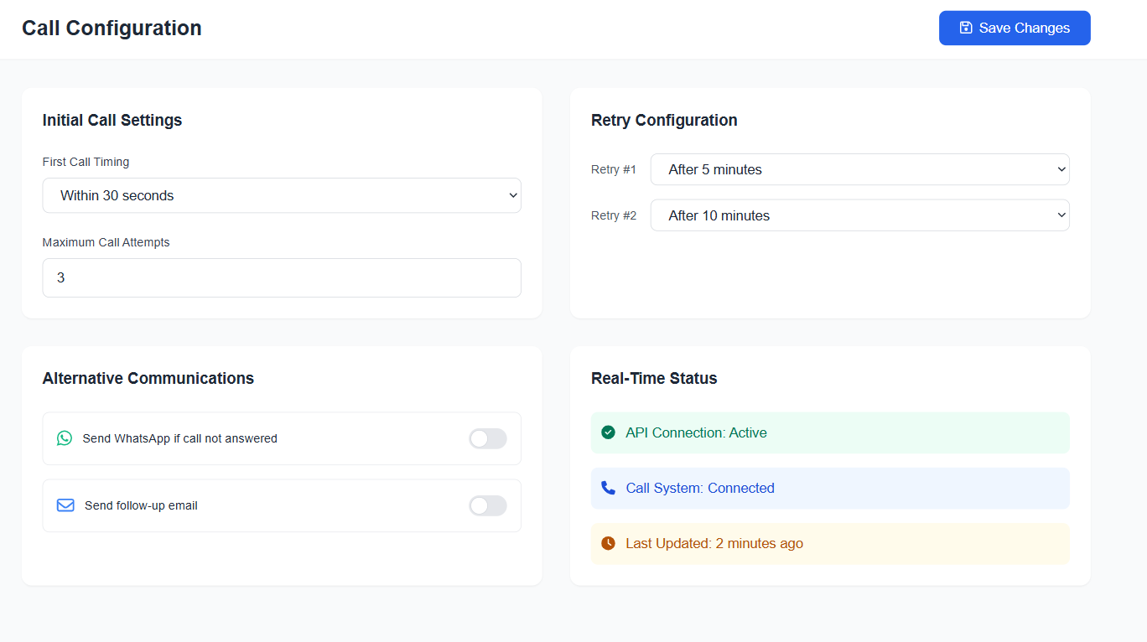

* Options to set call schedules and preferences:
  + Configure the time interval after receiving a lead (e.g., within 30 seconds, 2 minutes, 5 minutes, or custom time) for the first call.
  + Set intervals for retrying calls if the lead does not answer (e.g., retry after 5 minutes, 10 minutes, etc.).
  + Define the maximum number of call attempts.
* Allow configuration for alternate communication options:
  + Send a WhatsApp message to the lead if the call is not answered.
  + Send an email to the lead, including meeting details or follow-up information.
* Trigger call actions and API calls to backend.
  + **Key Elements**:
    - Scheduling Options, Save Button, Real-Time Status Display.

**4. Phone Number Management Screen**:

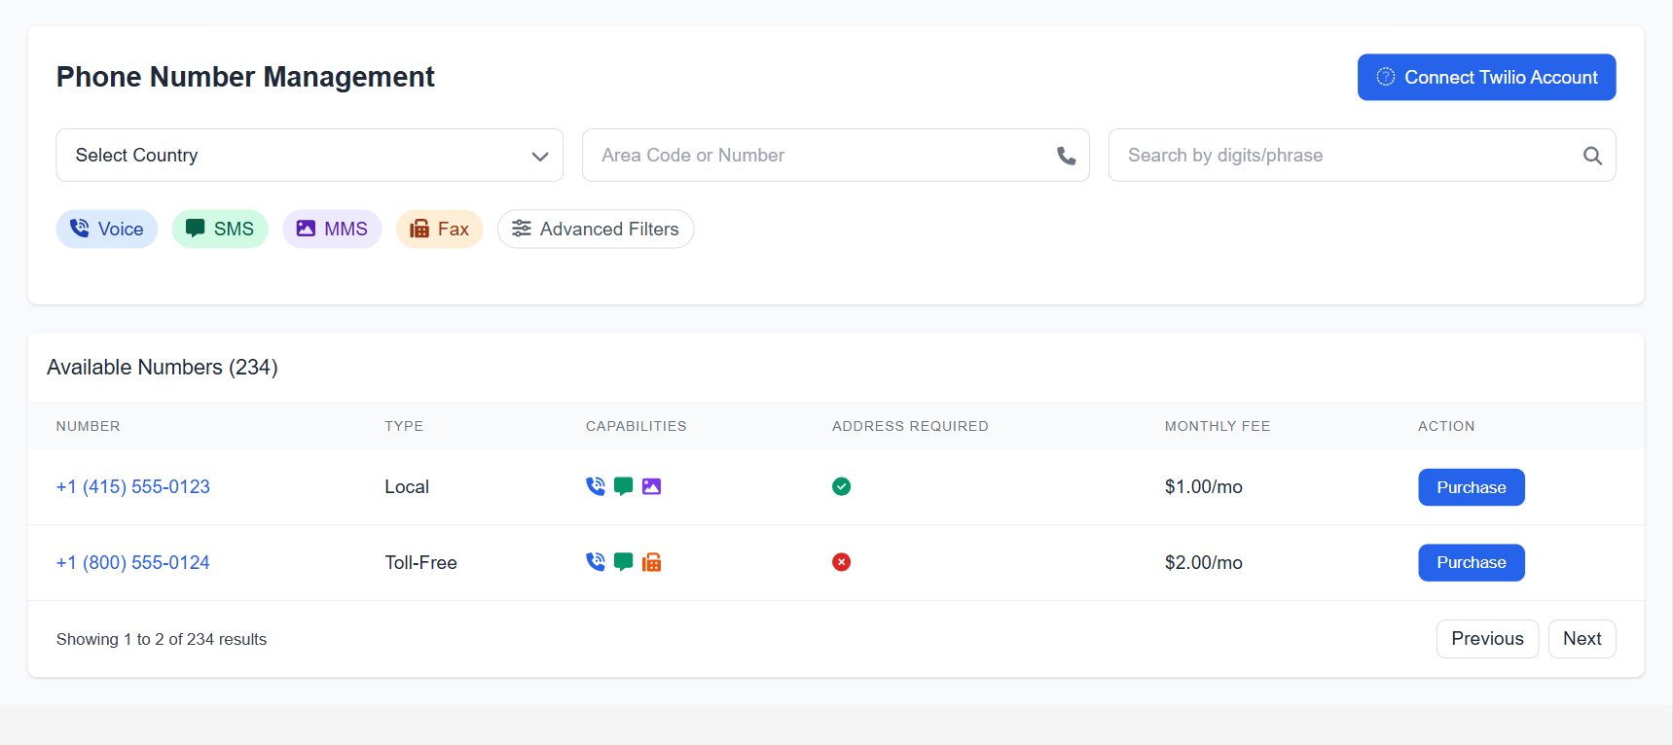

* Enable users to search for and purchase phone numbers with the following capabilities:
  + Search by country, area code, or specific digits/phrases.
  + Filter numbers based on capabilities like Voice, SMS, MMS, and Fax.
  + Advanced Search options for more refined filters.
  + Display results with details such as:
    - Number
    - Type (e.g., Local, Toll-Free)
    - Capabilities (e.g., Voice, SMS, MMS, Fax)
    - Address Requirements
    - Monthly Fee
* Allow users to integrate with Twilio and fetch all associated numbers for management within the platform.
* **Key Elements**:
  + Number Display, Purchase Options, Twilio Integration, Advanced Filters.

**5. Call Logs Screen**:

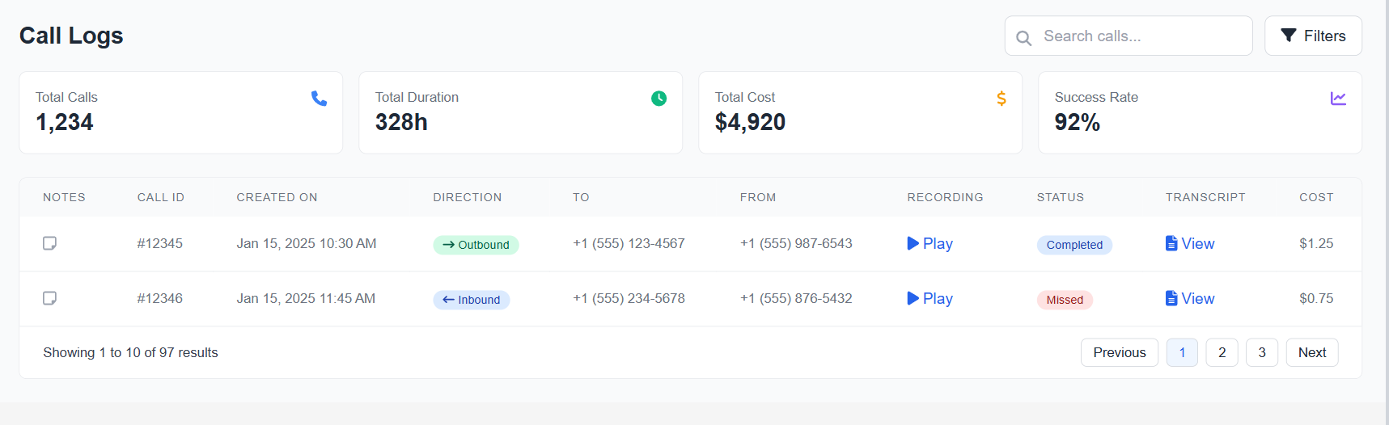

* Along with Total call, will also showcase the INBOUND call vs outbound call.
* Detailed logs of all calls with the following columns:
  + Notes
  + Call ID
  + Created On
  + Direction (Inbound/Outbound)
  + To
  + From
  + Recording (Link to recording)
  + Status (e.g., Completed, Missed)
  + Transcript (Link to transcript view)
* Cost calculation at $0.25/min.
  + **Key Elements**:
    - Call Details, Cost Breakdown, Filters, Search.

**5.1 Call Detail Screen**:

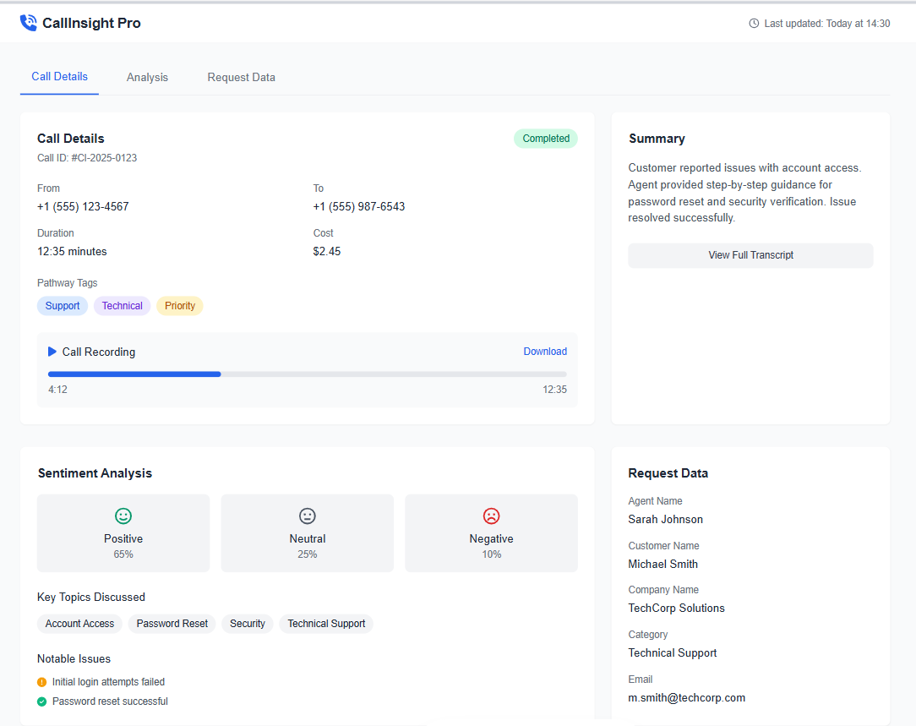

* This screen provides detailed insights about a specific call, including:
  + **Details Section**:
    - Call ID
    - To and From Numbers
    - Duration
    - Cost
    - Pathway Tags (e.g., related categories or topics discussed)
    - Recording (Link or embedded playback)
    - Created At (Timestamp)
  + **Summary Section**:
    - A concise summary of the call generated by the AI.
    - Transcript view for detailed analysis.
  + **Analysis Section**:
    - Sentiment analysis of the call (e.g., Positive, Neutral, Negative).
    - Topics discussed during the call.
    - Issues raised by the lead or customer.
  + **Request Data Section**:
    - Agent Name
    - Customer Name
    - Company Name
    - Category
    - Email

**6. Dashboard Screen**:

* Metrics and summaries of leads and call statuses.
* Visual widgets for status grouping.
  + **Key Elements**:
    - Metrics, Graphs, Filters, Status Grouping.

**7. Calendar Screen**:

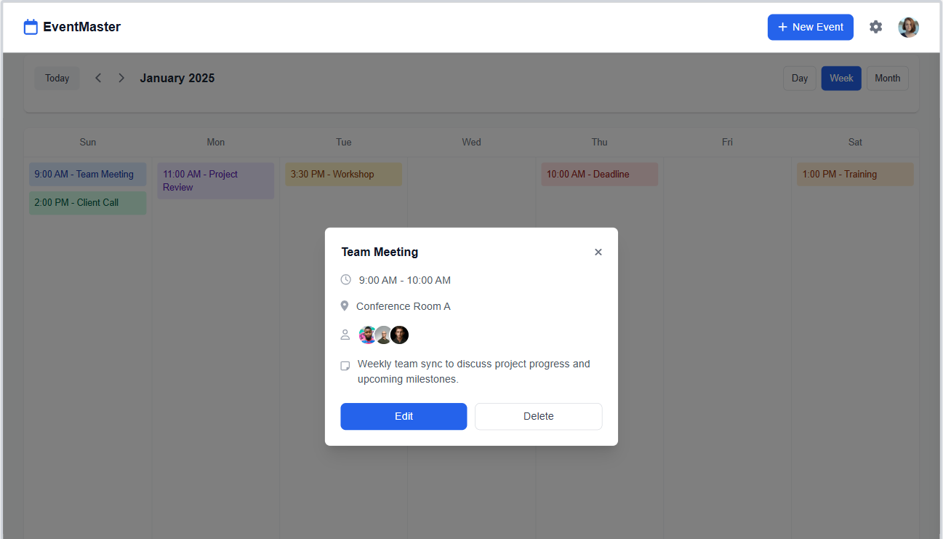

* Integrated view of scheduled meetings and appointments.
  + **Key Elements**:
    - Calendar Grid: Users can view events in different timeframes such as days, weeks, or months.
    - Events Display: Each section of the calendar showcases the scheduled events.
    - Event Details: Clicking on an event will open a detailed view showing all relevant information about the event.
    - Integration Settings: Options to sync with third-party platforms like Gmail, Outlook, and Calendly.

**8. Chatbot Screen**:

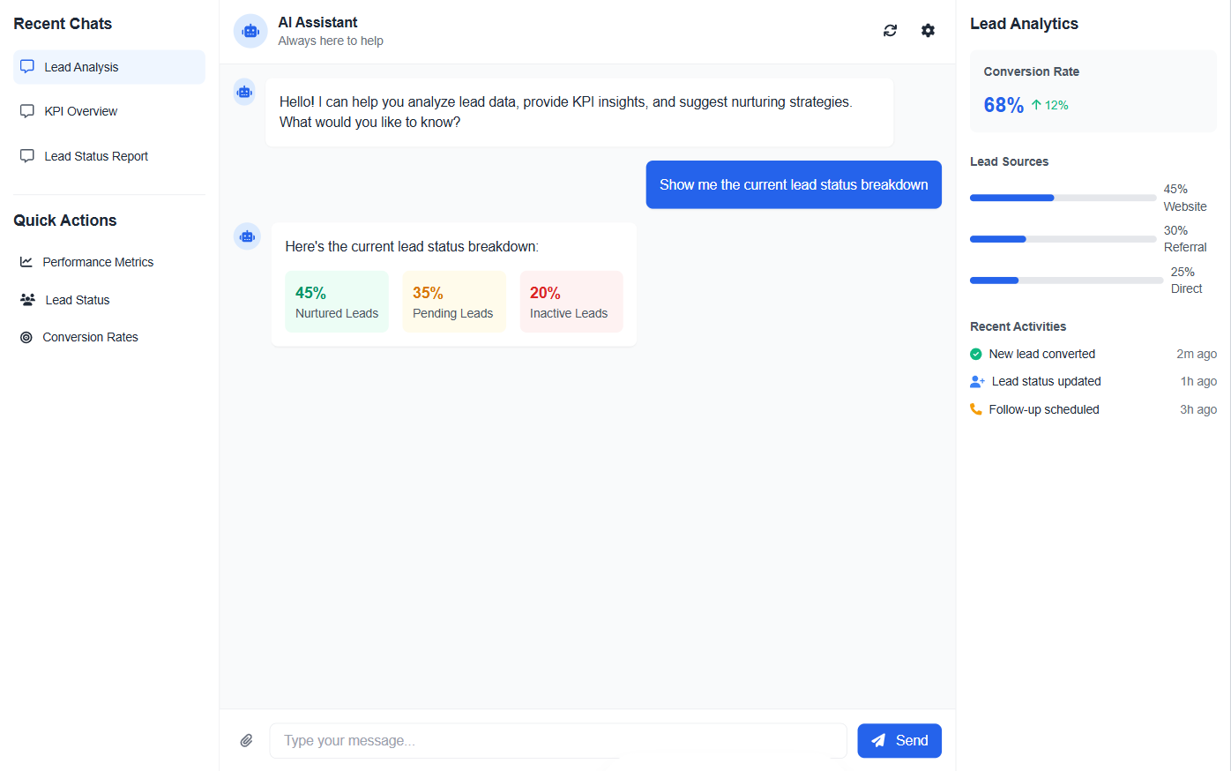

* Interactive interface for querying call data, transcripts, summaries, and lead statuses.
  + **Key Elements**:
    - Input Box, Chat Responses, Data Display.
  + **Expanded Functionality**:
    - Enable upper management or other users to interact with the chatbot for detailed insights such as:
      * Current lead statuses (e.g., pending, nurtured, or useless leads).
      * Key performance indicators such as total leads, conversion rates, and follow-up statuses.
      * Suggestions on how to nurture leads effectively.
    - Integrate the chatbot into the system to provide real-time updates and responses.

**Non-Functional Requirements**

1. **Performance**:
   * System must support high concurrent call volumes without latency.
2. **Security**:
   * Ensure data encryption for call recordings, transcripts, and payment information.
   * Implement secure authentication and authorization protocols.
3. **Scalability**:
   * System should handle scalability for growing tenant needs.
4. **Compliance**:
   * Adhere to GDPR and CCPA guidelines for data handling.

**Integration Requirements**

1. **Third-party Platforms**:
   * Meta, Google, HubSpot, Zapier, and LinkedIn Ads for lead imports.
   * Gmail, Outlook, and Calendly for scheduling.
2. **Payment Gateway**:
   * Stripe for transactions.
3. **Telephony**:
   * Twilio for phone number management and call APIs.

**Assumptions and Dependencies**

1. Tenants will provide required API keys and permissions for third-party integrations.
2. BLAND.AI and Twilio services are operational and accessible for backend integration.
3. Stripe account setup for payment gateway is completed.

**Risks and Mitigation**

1. **Risk**: Third-party API outages (e.g., Twilio, Stripe).
   * **Mitigation**: Implement fallback mechanisms and notify tenants of service disruptions.
2. **Risk**: Data privacy concerns.
   * **Mitigation**: Ensure compliance with relevant data protection regulations.

**Approval**:  
[Signatures of Stakeholders]